Steps to be followed: Ubuntu@ip-172-31-18-93:~/aws

* **Creating a cluster**
* **Installation of Docker**

1. Install AWS CLI – Command line tool

2. Install eksctl – A command line tool

3. install kubectl – A command line tool

Once you install all of the above, you need to have AWS credentials configured;

4. aws configure

Create EKS Cluster using eksctl;

5. eksctl create cluster --name demo-eks --region us-east-2 --nodegroup-name my-nodes --node-type t3.small --managed

(The eksctl tool uses CloudFormation under the hood)

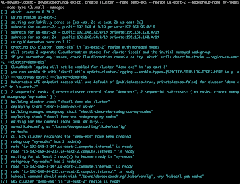

Connect to EKS cluster;

6. kubectl get nodes

https://1.bp.blogspot.com/-8tpK_USt5_Q/X4ZPAONKEDI/AAAAAAAADFw/fzrvmYdOCX8mNl5dwJnIWCFT5_od-ftkQCLcBGAsYHQ/s320/get%2Bnodes.png

7. kubectl get ns

Docker installation steps using default repository from Ubuntu;

8. sudo apt-get update

Install the below packages;

9. sudo apt install gnupg2 pass -y

Install docker;

10. sudo apt install docker.io -y

Add Ubuntu user to Docker group;

11. sudo usermod -aG docker $USER

We need to reload shell in order to have new group settings applied:

12. newgrp docker

The Docker service needs to be setup to run at startup;

13. sudo systemctl start docker

14. sudo systemctl enable docker

15. sudo systemctl status docker

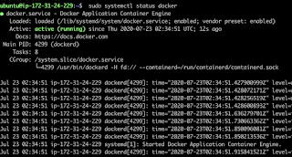

The Docker daemon is up and running.

### Now, 1. Install Docker on Ubuntu

1. **Install packages to allow apt to use a repository over HTTPS:** sudo apt -y install apt-transport-https ca-certificates curl software-properties-common
2. **Add Docker’s official GPG key:**  
   curl -fsSL https://download.docker.com/linux/ubuntu/gpg | sudo apt-key add -
3. **Add stable repository:**  
   sudo add-apt-repository "deb [arch=amd64] https://download.docker.com/linux/ubuntu $(lsb_release -cs) stable"

**4. Install Docker CE:**  
 sudo apt update && sudo apt -y install docker-ce

**Run the command below to see a version of docker installed;**  
🡪 docker version

Now, if you enter public IP (54.213.193.176 from EC2) on the browser, the following screen will appear.

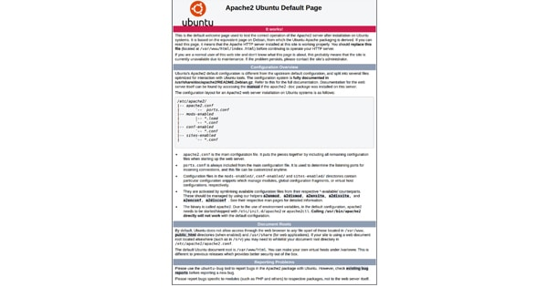

The End.